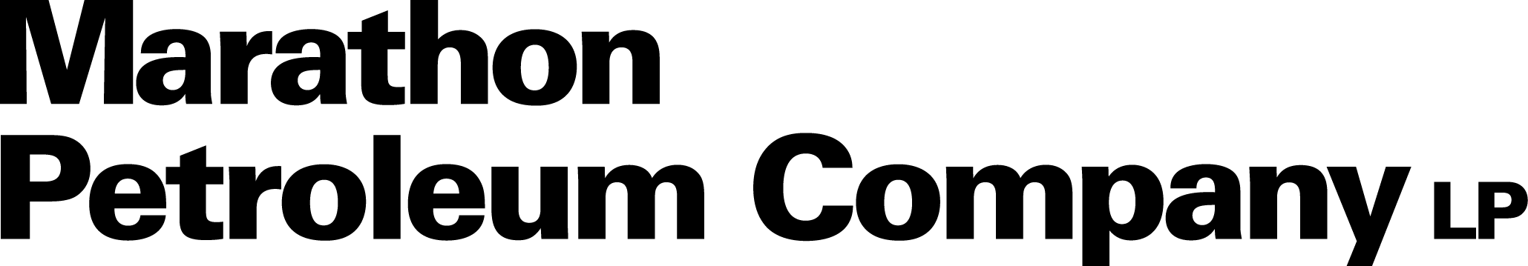

Value Tracking Automation (VRMS)
Value Realization for Value Chain Optimization
Solution Design Document

Document Version | 1.0
Date | September 2026
Client | Marathon Petroleum Company LP
Prepared By | Proclink Consulting Services LLP
Status | Draft for Review
Classification | Confidential
Prepared by


Document Revision History
Version | Date | Author | Reviewer | Description / Change
1.0 | September 2026 | Proclink Delivery Team |  | Initial draft for review
Document Approval Log
Role | Name / Position | Signature | Date
Prepared by | Proclink Delivery Team
Reviewed by
Verified by
Approved by

Table of Contents

1. Introduction
Marathon Petroleum Company LP (MPC) has established a Value Realization framework for Value Chain Optimization (VCO) initiatives. The framework defines the value-tree structure, standardized actions, formula archetypes, baselines, allocation methods, governance roles, review cadence, and reporting expectations used to capture and report value consistently across VCO initiatives.
The Value Record Management Solution (VRMS) — the Value Tracking Automation initiative — operationalizes this approved framework through a controlled, supportable, and auditable digital capability. Value events are currently recorded in the RVCO Commercial Value Add SharePoint list, while subsequent validation, reconciliation, allocation, workflow, and reporting activities remain partially manual or are completed through separate tools and communications. VRMS automates and strengthens value capture, validation, calculation, allocation, review, approval, reconciliation, reporting enablement, administration, and auditability.
MPC has selected SharePoint Online as the operational system of record, Power Apps as the application layer, Power Automate as the workflow and notification technology, and Power BI as the reporting and visualization platform. AI-assisted classification supports users in applying the approved Value Realization classifications. MPC’s internal Dashboarding team leads final dashboard build, publication, and ongoing administration.

1.1 Document Overview
This Solution Design Document (SDD) provides a high-level solution and functional architecture overview of VRMS. The document describes the overall solution architecture, solution components, business process and workflow design, functional scope, AI-assisted classification approach, reporting enablement, role-based access model, implementation approach, assumptions, exclusions, and risks associated with the implementation.
The document is intended to serve as a reference for business stakeholders, solution architects, functional leads, developers, testers, administrators, and support teams involved in the design, delivery, and operation of the solution. Detailed implementation specifications, list schemas, application formulas, flow configurations, data flows, reporting technical definitions, and environment/deployment details are documented separately in the VRMS Technical Design Document (TDD).

1.2 Scope
The scope of this engagement is the enhancement of the existing RVCO Commercial Value Add SharePoint solution into an automated, governed value-tracking capability delivered on Company-approved SharePoint Online, Microsoft Lists, Power Apps, Power Automate, Microsoft Entra ID, approved AI capabilities, and Power BI reporting enablement.
In scope. The Base Scope includes the functional, technical, AI, project-management, testing, deployment, training, transition, and commercial requirements stated in the Statement of Work. The solution delivers standardized value-record creation and maintenance, AI-assisted classification, deterministic validation and calculation, allocation and aggregation, role-based review and endorsement, financial reconciliation, reporting-ready data and security definitions, role-based access, administration, monitoring, and audit history.
Out of scope. Items excluded unless expressly approved through change control include material redesign of the approved Value Realization methodology; final Power BI dashboard and semantic-model development, publication, and administration (owned by Company Dashboarding); expansion to additional organizations, populations, personas, workflows, or reporting outputs beyond the approved requirements baseline; and new platform products, premium/custom connectors, or external services not disclosed and approved. Refer to Section 8 for the full list of assumptions and exclusions.

1.3 Related Documents
Sr. No. | Document Name | Description
1 | SOW BK082026 — Value Tracking Automation | Statement of Work defining scope, deliverables, responsibilities, schedule, fees, assumptions, exclusions, and acceptance criteria.
2 | VRMS Technical Implementation Guide for POC | Step-by-step build guide for the value-record lifecycle Proof of Concept (Power Apps + Power Automate + SharePoint Online).
3 | VRMS Reference Architecture Diagram | Conceptual Power Platform reference architecture for the Value Tracking Automation solution.
4 | VRMS Technical Design Document | Companion technical design detailing implementation, configuration, data flows, and technical components.
5 | Company Value Case Report / Value Methodology & Calculation Framework / Value Tracking Governance & Cadence Framework | Company-approved business baseline (incorporated project baseline).

2. Solution Overview

2.1 Business Objective
The business objective of VRMS is to provide a centralized, governed, and auditable capability that operationalizes MPC’s approved Value Realization framework — enabling value events to be created, classified, validated, calculated, allocated, reviewed, endorsed, reconciled, and reported consistently across VCO initiatives while preserving required human review and decision authority.
The solution standardizes value-record creation and calculation methodology, reduces manual effort, improves data quality and traceability, and provides reporting-ready data for Company-owned Power BI reporting. MPC retains ownership and approval authority for the Value Realization framework, value-tree structure, standardized actions, formulas, baselines, financial-attribution rules, governance decisions, business acceptance, and production deployment.
Guiding principle. The solution shall preserve required human review and decision authority. Neither deterministic automation nor AI-assisted functionality may independently approve, endorse, certify, or publish a value record.

2.2 Value Tracking Process
VRMS supports a Company-approved, multi-stage governance workflow covering value submission, validation, calculation, allocation, review, endorsement, financial reconciliation, reporting, correction, and closure. The workflow supports configurable roles, routing, decision authority, delegation, reassignment, reminders, escalation, return, rejection, reopening, and exception handling.
The final workflow stages, role assignments, field-edit permissions, and approval authorities are validated against the approved Value Tracking Governance and Cadence framework and approved by Company at Gate 1 before workflow configuration begins. The monthly governance cycle (submission deadlines, review activities, reconciliation timing, escalation points, reporting cutoffs, and status checkpoints) is administratively maintainable and not hard-coded.

2.3 Key Capabilities
The solution provides the following integrated capabilities:
- Standardized, role-based value-record creation and maintenance using Company-approved value-tree classifications, standardized actions, formulas, baselines, and required supporting information.
- AI-assisted recommendations for value chain stage, value chain subcategory, value lever, standardized action, formula, and baseline — subject to confidence scoring, explanation, user review, and override.
- Deterministic validation of required fields, data formats, ranges, cross-field consistency, evidence, duplicates, overlaps, and other Company-approved controls.
- Company-approved calculation, allocation, aggregation, attribution, period, run-rate, reconciliation, and variance rules.
- Configurable review, endorsement, approval, correction, delegation, reassignment, escalation, and exception workflows.
- Reporting-ready data, operational views, KPI and measure specifications, reconciliation logic, and security definitions supporting Company-owned Power BI reporting.
- Role-based access, segregation of duties, administrative controls, monitoring, audit history, and configuration management.
- A supportable architecture that may accommodate future expansion, within the boundaries of the approved requirements baseline.

3. Solution Architecture
VRMS is designed as a layered Microsoft Power Platform solution built on SharePoint Online. The architecture separates the user experience, operational data, workflow and business rules, AI assistance, identity and access, and reporting enablement so that each concern can be configured, secured, tested, and supported independently. The reference architecture below is a conceptual illustration; the final architecture, component responsibilities, data flows, security design, and reporting boundaries are subject to Gate 1 approval.

3.1 Reference Architecture
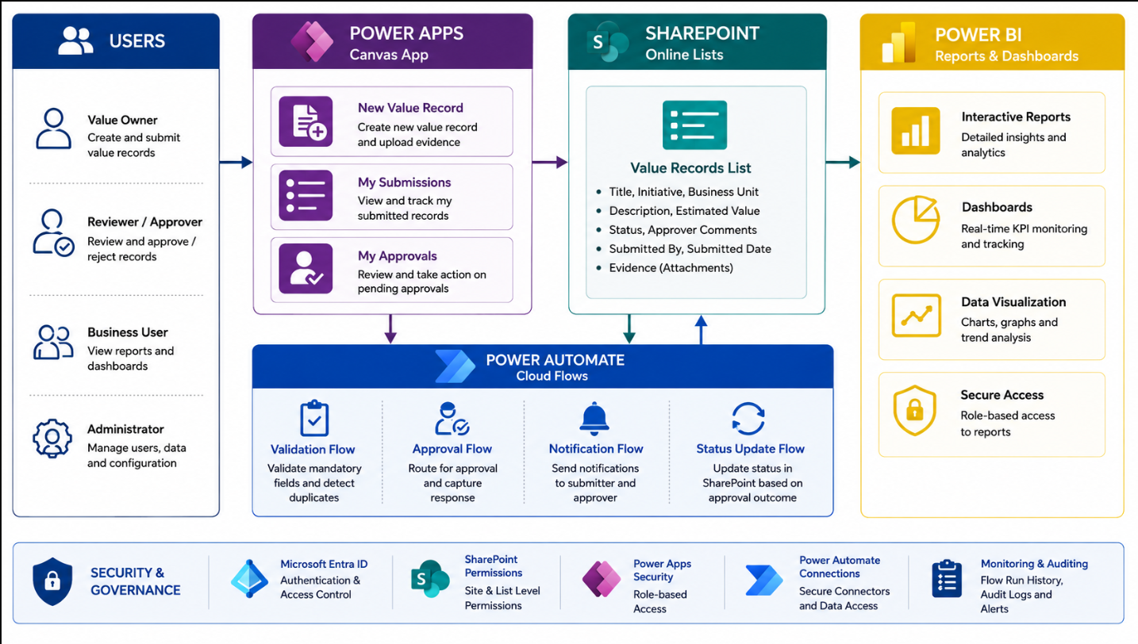
Figure 1: VRMS Reference Architecture (conceptual)
Users access the solution through Microsoft 365 authentication. The Power Apps canvas application provides the value-record experience (New Value Record, My Submissions, My Approvals). SharePoint Online lists serve as the operational system of record. Power Automate cloud flows provide validation, approval routing, notification, and status management. Power BI delivers interactive reports and dashboards on top of reporting-ready data. Security and governance are applied consistently across Microsoft Entra ID, SharePoint permissions, Power Apps security, Power Automate connections, and monitoring/auditing.

3.2 Solution Architecture Components
The solution is composed of the following components, aligned to the approved technology direction:
Component | Approved Direction / Role
User Experience | Power Apps canvas application (or other Company-approved SharePoint/Power Platform experience) providing value-record creation, work queues, review, and administration.
Operational Data | Existing RVCO SharePoint solution enhanced through SharePoint Online and Microsoft Lists as the Base-Scope operational data platform.
Workflow & Rules | Power Automate cloud flows and approved deterministic business-rule components for validation, routing, calculation support, reconciliation support, locking, and notifications.
AI Assistance | Company-approved AI services integrated with the form and controlled vocabularies to recommend approved classifications and calculation references, subject to human review and override.
Identity & Access | Microsoft Entra ID with approved role-based access groups, applied across SharePoint, Power Apps, and Power BI Row-Level Security.
Reporting | Reporting-ready data structures, views, KPI/measure specifications, reconciliation logic, and security requirements supporting Company-owned Power BI development.
Evidence & Audit | Company-approved storage, metadata, retention, and audit design preserving record traceability across value records, workflow actions, calculations, AI recommendations, overrides, approvals, and administrative changes.
Administration | Configurable management of approved master data, roles, routing, deadlines, notifications, business rules, and AI reference content.

3.3 Solution Layers

3.3.1 Presentation Layer — Users & Power Apps
The presentation layer delivers a unified and supportable value-record experience. Personas include the Value Owner (creates and submits value records), Reviewer/Approver (reviews and approves or rejects records), Business User (views reports and dashboards), and Administrator (manages users, data, and configuration). The application supports creation, editing, submission and tracking of value records; entry of supporting evidence and calculation inputs; presentation and disposition of AI-assisted recommendations; personal and role-based work queues; review, endorsement, reconciliation, approval, return, rejection, delegation, reassignment, closure, and reopening; and administrative maintenance of approved reference content.

3.3.2 Data Layer — SharePoint Online
SharePoint Online and Microsoft Lists are the approved Base-Scope operational data platform. The data design covers value-record, supporting-evidence, reference-data, formula, baseline, allocation, workflow-configuration, AI-recommendation, and audit-history structures, together with the volume, performance, evidence-management, retention, and reporting requirements defined in the Technical Design Document.

3.3.3 Automation Layer — Power Automate
Power Automate cloud flows implement the deterministic automation that supports the human governance workflow: submission validation, workflow routing and decisions, calculation/allocation/reconciliation support, record locking and status management, archiving and retention (where approved), and configurable notifications, reminders, and escalations.

3.3.4 Analytics Layer — Power BI
The analytics layer consumes reporting-ready data to deliver interactive reports, dashboards, KPI monitoring, and data visualization with secure, role-based access. VRMS delivers the reporting-enablement inputs; Company Dashboarding owns building, publishing, and administering the final Power BI reports.

4. Functional Design

4.1 Functional Scope
The functional design operationalizes MPC’s approved Value Realization framework, beginning from the approved Phase 1 deliverables and applicable Company reference data. The functional scope addresses:
- Value-record lifecycle and status model.
- Value-tree classifications and standardized actions.
- Formula and baseline presentation and application.
- Validation, duplicate, overlap, exception, and reconciliation rules.
- Allocation and aggregation methodology.
- Governance roles, workflow stages, decision rights, and escalation paths.
- Monthly-cycle deadlines and reporting states.
- Field-level access and editability.
- Administrative and support requirements.
- AI-assisted recommendation behavior and controls.
- Reporting, testing, deployment, training, hypercare, and acceptance requirements.

4.2 Value-Record Lifecycle
A value record progresses through a governed lifecycle of statuses aligned to the approved governance workflow. The illustrative status model below is validated and confirmed at Gate 1.
Stage | Description
Draft | Value Owner creates the record and enters required information, evidence, and calculation inputs. AI-assisted recommendations are presented for review and disposition.
Submitted | Record is submitted for automated validation.
Validated | Deterministic validation confirms required fields, formats, ranges, cross-field consistency, evidence, and duplicate/overlap checks.
In Review / Pending Approval | Record is routed to the approved reviewer, endorser, and financial-reconciliation roles per the role model.
Approved / Endorsed | Record receives required human endorsement and approval; it becomes reporting-ready.
Returned / Rejected | Record is returned for correction or rejected, capturing comments, owner, timestamp, prior status, new status, and reason.
Closed | Record is closed per approved rules; reopening is a controlled process with audit history and approved authority.

4.3 Power Apps Application Layer
The application provides a role-based experience whose structure, navigation, screens, forms, queues, actions, and administrative experiences are based on the approved requirements, workflow, role model, record status, field-level permissions, and segregation-of-duties requirements. A role and field-level access matrix identifies — by workflow state — which approved roles may view, create, edit, submit, review, recommend, accept or override an AI recommendation, return, reject, endorse, approve, reconcile, reopen, close, administer, and report each applicable field or record. Company approves the matrix before related configuration is accepted, and it is validated through testing before production deployment.

4.4 AI-Assisted Value Classification
VRMS includes an AI-assisted capability that analyzes Company-approved value-record inputs and recommends applicable Value Realization classifications and calculation references. Based on the information entered or attached to a value record and the approved Company reference content, the capability recommends — where sufficient information exists — value chain stage, value chain subcategory, value lever, standardized action, applicable formula archetype or approved formula, and applicable baseline or baseline category.
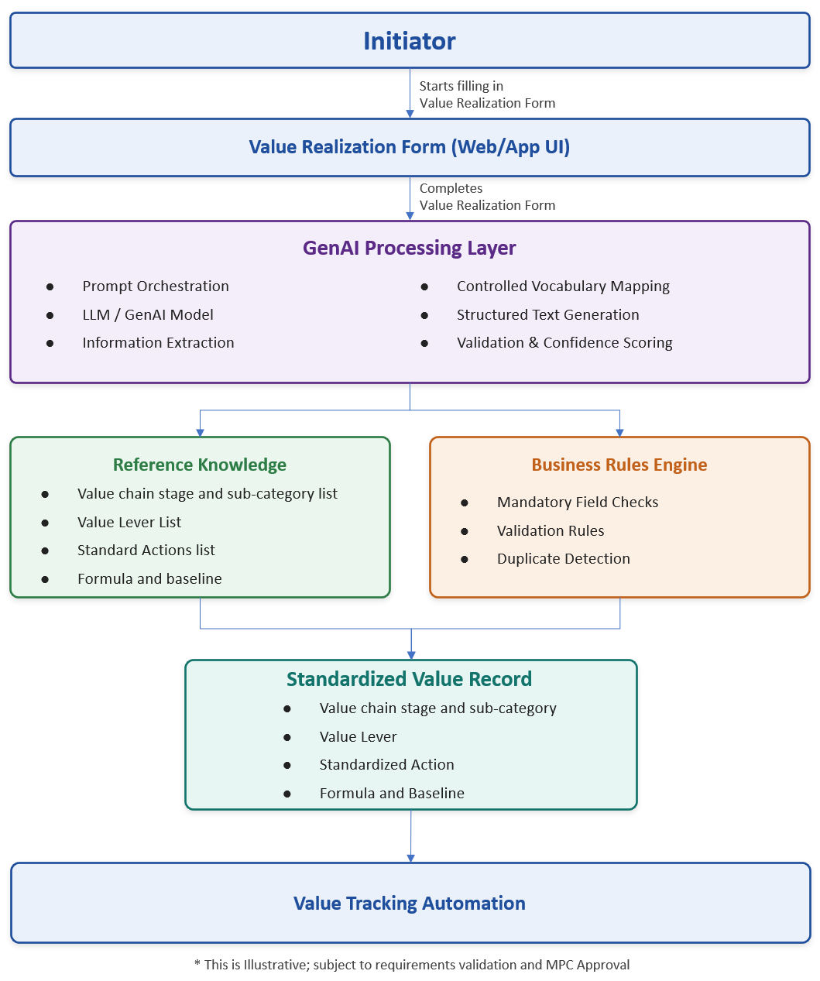
Figure 2: Conceptual AI-Assisted Value Classification Architecture (illustrative; subject to requirements validation and MPC approval)
Controlled recommendations. Recommendations are limited to Company-approved controlled vocabularies, formulas, baselines, standardized actions, and reference content. The AI capability does not create or independently approve a new classification, standardized action, formula, baseline, allocation rule, workflow rule, or reporting definition.
Human review. AI-generated recommendations are clearly identified. For each recommendation, the authorized user reviews the suggested value, an applicable confidence indicator, and an explanation or reason code, and may accept the recommendation, select another approved value, or indicate that no approved option is appropriate and route the record for governed review. AI does not independently submit, approve, endorse, certify, reconcile, publish, close, or materially modify an approved value record.
Fail-safe behavior. AI assistance fails safely. Core value-record creation, deterministic validation, calculation, allocation, workflow, reconciliation, and reporting-enablement functions remain usable if the AI capability is unavailable.

4.5 Reporting Enablement
VRMS delivers reporting-ready views and datasets; Company’s Dashboarding team owns building and publishing the final Power BI reports. The reporting-enablement design provides Company-approved source structures, reporting-ready views or datasets, source-field mappings, KPI and measure definitions, calculation and reconciliation logic, reporting states, security requirements, test support, documentation, and handoff materials. Row-Level Security, default views, role-based report behavior, executive views, administrative views, and access boundaries are validated and approved by Company before implementation.
Reporting Item | Required Content
Reporting requirements | Audiences, report categories, dimensions, filters, reporting states, operational views, executive views, exception views, AI monitoring needs, and required outputs.
Source-field mapping | Source field, data type, business definition, transformation, owner, security treatment, and report usage.
KPI & measure definitions | Calculation logic, included and excluded records, aggregation, tolerance, owner, reporting state, and reconciliation approach.
Reconciliation logic | Source-to-report checks, expected results, exceptions, correction process, and sign-off requirements.
Security requirements | Row-Level Security approach, access groups, role assumptions, access boundaries, and access-testing evidence.
AI reporting requirements | Recommendation volumes, confidence distribution, acceptance and override rates, exceptions, unresolved low-confidence items, and recommendation results based on approved human disposition.
Handoff documentation | Documentation sufficient for Company Dashboarding to build, validate, publish, administer, and support assigned Power BI outputs without recreating Consultant-developed logic.

5. Business Process & Workflow Design

5.1 Governance Workflow
The solution implements a Company-approved human governance workflow supported by deterministic automation and AI assistance. The workflow addresses value-record creation, validation, AI recommendation review, calculation, allocation, business review, endorsement, financial reconciliation, approval, reporting readiness, correction, rejection, closure, reopening, delegation, reassignment, escalation, and administration. Segregation of duties is enforced so that an Initiator cannot approve their own record.

5.2 Workflow Pattern
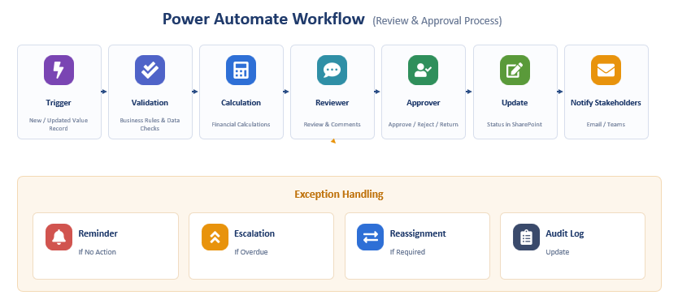
Figure 3: Power Automate Review & Approval Process (illustrative)
The review-and-approval process moves a value record through trigger, validation (business rules and data checks), calculation (financial calculations), reviewer (review and comments), approver (approve / reject / return), status update, and stakeholder notification. Exception handling provides reminders (if no action), escalation (if overdue), reassignment (if required), and audit-log updates. No workflow illustration is treated as an approved final workflow unless incorporated into the Gate 1-approved design.

5.3 Workflow Capabilities
Workflow Capability | Requirement
Routing | Configurable by approved business rules and role model.
Return / Rejection | Must capture comments, owner, timestamp, prior status, new status, and reason.
Delegation / Reassignment | Must be auditable and distinguish delegated actions.
Escalation | Configurable deadlines, reminder timing, escalation recipients, and overdue visibility.
Reopening / Correction | Controlled process with audit history and approved authority.
Status Locking | Approved rules for when records become locked, editable, reopened, closed, or published.
Error Handling | Flow failures must be monitored, logged, triaged, and resolved.
Audit History | Retain actor, action, timestamp, affected record, prior state, new state, and comments where applicable.
Monthly Governance Cycle | Support Company-approved submission deadlines, review activities, reconciliation timing, escalation points, reporting cutoffs, and status checkpoints without hard-coding administrable dates.
AI Recommendation Disposition | Retain the recommendation, confidence indicator, explanation or reason code, user acceptance or override, final selection, user, timestamp, and applicable model or configuration version.

6. Role-Based Access & Security Model
Role-Based Access Control (RBAC) is implemented through Microsoft Entra ID security groups mapped to Company-approved roles, personas, groups, access levels, workflow responsibilities, administrative responsibilities, reporting responsibilities, support responsibilities, and segregation-of-duties requirements. RBAC is applied consistently across SharePoint site permissions, the Power Apps application, and Power BI Row-Level Security. Segregation of duties is enforced so an Initiator cannot approve their own record.
The solution supports approved provisioning, role changes, temporary access, delegation, reassignment, periodic access review, privileged access controls, deprovisioning, and access-removal processes. Business-role authority and technical administration are treated separately: administrative or technical access does not, by itself, authorize a user to submit, endorse, approve, reconcile, publish, or close a value record. AI service identities, application identities, connections, and service accounts use least privilege and are included in the approved access, monitoring, and support model.
Security Domain | Control / Description
Identity & Access | Microsoft Entra ID authentication with RBAC security groups mapped to approved roles and personas, applied across SharePoint, Power Apps, and Power BI.
Segregation of Duties | Enforced across the workflow (for example, an Initiator cannot approve their own record); separation of business-role authority from technical administration.
Least Privilege | Service identities, application identities, and connections operate with least privilege and are monitored.
Row-Level Security | Power BI RLS restricts data visibility by role and scope; validated and approved before implementation.
Auditability | Material audit history for value records, workflow actions, calculations, allocations, AI recommendations, overrides, approvals, corrections, and administrative changes.
Administration & Monitoring | Configurable administrative capabilities, configuration management, and monitoring of workflow and integration health.

7. Implementation Approach

7.1 Project Life Cycle
VRMS follows a phased, iterative life cycle with strong domain validation by business and SME stakeholders at each step. Outcomes are reviewed and approved by stakeholders with attention to data quality, domain alignment, and reporting requirements. No production configuration or build begins before Gate 1 approval. Consultant prototyping during requirements and design may clarify requirements and demonstrate alternatives, but prototype outputs do not constitute approved design, production configuration, UAT approval, acceptance, or authorization for additional cost.

7.2 Delivery Approach
Delivery combines controlled requirements and design gates with incremental configuration, demonstration, testing, and business feedback. Design activities may include process walkthroughs, visual prototypes, screen mockups, configuration examples, and demonstrations to clarify requirements and design decisions. The Consultant interacts directly and regularly with designated Company business, functional, technical, reporting, security, and support participants; incrementally demonstrates configured capabilities; and documents resulting decisions, actions, defects, and approved requirement clarifications.

7.3 Key Activities & Deliverables
Phase | Key Activities | Deliverable
Mobilization | Confirm governance, decision rights, delivery approach, staffing, schedule, dependencies, project controls, gate requirements, acceptance approach, and required Company participation. | Mobilization & Project Controls
Requirements & Process Design | Validate the Phase 1 baseline; define the implementation-ready process, value-record lifecycle, roles, workflow, business rules, AI behavior and controls, reporting requirements, exceptions, administration, test basis, and acceptance criteria. | Requirements & Process Design
Technical & Solution Design | Define the approved architecture, data model, user experience, workflows, calculations, allocations, AI services and controls, reporting enablement, security, administration, environments, deployment, monitoring, and support. | Technical & Solution Design
Build & Configuration | Configure the value-record application, data structures, deterministic workflows, validations, calculations, allocations, reconciliation, notifications, audit capabilities, AI-assisted recommendations, reporting-ready structures, security, and administration. | Configured Value Tracking Capability & Reporting Enablement Package
Consultant Testing & UAT | Complete requirements-traceable testing across functional, workflow, security, calculation, allocation, reporting, AI, performance, deployment, and operational readiness; prepare and support Company-led UAT; manage defects. | Testing & UAT Package
Training & Operational Readiness | Deliver role-based business, administrative, reporting, technical, and support training; complete knowledge transfer, runbooks, support ownership, and readiness assessment. | Training & Operational Readiness Package
Deployment & Go-Live | Prepare cutover, rollback, release, and validation plans; support production deployment and validate workflows, calculations, allocations, AI behavior, notifications, audit history, security, reporting structures, and administration. | Deployment & Go-Live Package
Hypercare, Transition & Closeout | Monitor production operation, support the first applicable governance cycle, triage issues, correct defects, complete handoff, archive project records, and obtain final acceptance. | Hypercare & First-Cycle Stabilization Package and Closeout Repository

7.4 Governance & Decision Gates
The engagement uses a weekly project review, working sessions, and formal decision-gate reviews authorizing progression to the next phase. A gate review is a decision point, not a separate deliverable; authorization to proceed does not waive incomplete deliverables, outstanding defects, or required rework.
Gate | Purpose
Gate 1 — Requirements & Design Approval | Approve the Base-Scope requirements, future-state process, architecture, AI controls, roles, environments, integrated schedule, test basis, and acceptance criteria; authorize Base-Scope build.
Gate 2 — Testing Readiness | Confirm that configuration and required Consultant testing are sufficiently complete to begin Company-led UAT.
Gate 3 — UAT Approval & Production Go/No-Go | Confirm UAT approval, defect disposition, security and operational readiness, training readiness, cutover and rollback readiness, and authorization to deploy.
Gate 4 — Hypercare Exit & Final Acceptance | Confirm stabilization, first-cycle support, documentation, knowledge transfer, support handoff, open-item disposition, and completion of the Base Scope.

7.5 Estimated Timeline
The engagement is delivered over a consecutive 12-week term (indicative Project Start: 17 August 2026; Project End: 20 November 2026). The integrated schedule is confirmed in the approved project plan.
Project Period | Primary Outcome | Decision Point
Weeks 1–2 | Mobilization, requirements validation, process design, AI controls, architecture, responsibilities, test basis, and acceptance criteria. | Gate 1
Weeks 3–8 | Configuration, AI capability, incremental demonstrations, Consultant testing, documentation, and UAT preparation. | Gate 2
Weeks 9–10 | Company-led UAT, training, defect disposition, production-readiness confirmation, deployment, and production validation. | Gate 3
Weeks 11–12 | Hypercare, first-cycle support, stabilization, transition, and closeout. | Gate 4

8. Assumptions and Exclusions

8.1 Assumptions
- Company will provide the available Phase 1 deliverables, reference data, current SharePoint solution, process materials, report samples, and identified business owners.
- The Consultant will validate the implementation requirements and will not assume that the Phase 1 documents constitute a completed technical or functional design.
- Company will provide required environments, currently available licenses, identities, service accounts, repositories, and test access according to the approved integrated schedule.
- SharePoint Online and Microsoft Lists are the Base-Scope operational data platform unless Company approves an alternative.
- Company Dashboarding will build and publish assigned Power BI outputs; the Consultant remains responsible for reporting requirements, source structures, mappings, KPI/measure specifications, calculation and reconciliation logic, security requirements, test support, and handoff.
- Company will identify business, technical, security, reporting, UAT, operational, and support decision owners.
- The engagement will be delivered primarily remotely unless Company approves specific travel.
- AI-Assisted Value Classification is included in the Base Scope; the Consultant will disclose all AI licensing, service, connector, consumption, external-processing, hosting, and recurring-cost requirements before Gate 1 approval.

8.2 Exclusions
Unless expressly included in the SOW or approved through change control, the following are excluded:
- Material redesign of Company’s approved Value Realization methodology.
- Replacement or enterprise redesign of Company source systems, financial systems, reporting platforms, identity services, cybersecurity architecture, PMO tools, or other enterprise systems.
- Automated integrations, data feeds, historical conversion, archive conversion, source-data remediation, or source-system correction not identified in the approved Base Scope.
- New platform products, premium connectors, custom connectors, third-party services, external hosting, licenses, subscriptions, or recurring services not disclosed and approved in the SOW.
- Final Power BI dashboard and semantic-model development, workspace administration, publication, access administration, monitoring, and ongoing support assigned to Company Dashboarding.
- Expansion to additional organizations, populations, regions, sites, personas, workflows, use cases, reports, or data sources beyond the approved requirements baseline.
- AI-generated narrative reporting, natural-language querying, predictive value forecasting, autonomous decision-making, or autonomous approval.
- Ongoing managed services or production support after the approved hypercare and transition period.

9. Risks and Mitigations
Risk | Potential Impact | Mitigation
Phase 1 materials contain unresolved comments, inconsistencies, or incomplete implementation details. | Gate 1 delay or configuration rework. | Prepare a consolidated requirements crosswalk and decision log during Mobilization; assign prioritized decisions to named owners and manage through escalation.
Required fields or field-level permissions are not finalized. | Delayed configuration, access-control rework, or segregation-of-duties issues. | Validate the field inventory and role/field-level access matrix during requirements and design; obtain Company approval through Gate 1.
Workflow paths, exception handling, or decision authority are incomplete. | Workflow rework or governance gaps. | Validate the complete lifecycle against the approved Phase 1 governance baseline before treating a discovered path as additional scope.
Formula, baseline, allocation, overlap, or reconciliation rules are incomplete or not sufficiently testable. | Incorrect calculations, attribution, reconciliation, or reporting. | Prepare approved business-rule inventories, representative scenarios, input data, expected results, tolerances, and exception treatments; trace each rule to configuration and testing evidence.
AI recommendations do not meet approved acceptance thresholds. | Reduced user confidence, increased manual effort, or delayed production approval. | Establish the representative test set, recommendation-specific thresholds, confidence behavior, error handling, and fallback at Gate 1; correct deficiencies and retest before production approval.
AI service, connector, licensing, external-processing, or data-treatment requirements are not approved. | AI delivery delay, unforeseen cost, or required architecture change. | Disclose all AI components, data flows, processing locations, retention, licensing, consumption costs, connectors, and alternatives during design; obtain approvals before implementation.
SharePoint volume, evidence storage, or usage patterns exceed approved design assumptions. | Performance degradation, capacity constraints, or architecture rework. | Document volume, evidence, usage, indexing, query, retention, and performance assumptions during design; validate the architecture against measurable requirements before Gate 1.
Company decisions, environments, identities, test data, or participants are not available when required. | Schedule delay or compressed testing and readiness activities. | Identify required inputs, participants, preparation, owners, and decision dates in the integrated schedule; escalate risks with decision, due date, alternatives, and impact.
Dependency on Company Dashboarding delays final reporting outputs. | Reporting validation or production-readiness delay. | Provide reporting requirements, structures, mappings, calculations, reconciliation logic, security, test data, and handoff per the schedule; coordinate early reviews with Company Dashboarding.
Twelve-week delivery schedule compresses requirements, testing, training, or deployment. | Reduced quality, incomplete readiness, or delayed acceptance. | Maintain the critical path and decision calendar; prepare testing and training early; use incremental demonstrations; execute a recovery plan when performance places the schedule at risk.

Appendix A — Glossary & Acronyms
Term / Acronym | Definition
VRMS | Value Record Management Solution — the Value Tracking Automation capability.
VCO | Value Chain Optimization.
RVCO | The existing Commercial Value Add SharePoint solution / list used to record VCO value events.
Value Record | A record capturing a value event with its classification, calculation inputs, evidence, and status.
Value Tree | Company-approved classification structure (value chain stage, subcategory, value lever).
Standardized Action | Company-approved action associated with value realization.
Baseline | Approved reference point used in value calculation.
RBAC | Role-Based Access Control.
RLS | Row-Level Security (Power BI).
SoD | Segregation of Duties.
Entra ID | Microsoft Entra ID — enterprise identity and access management.
UAT | User Acceptance Testing.
Gate 1–4 | Decision gates authorizing progression across the delivery life cycle.
TBD / TBC | To Be Determined / To Be Confirmed — to be resolved during requirements and design.

